Lab 1

# Bubblebee2 Stereo Vision Camera

The purpose of this experiment is to capture images from a stereo camera array and to extract a depth image from the two images. The Bubblebee2 Stereo Vision Camera is simply two cameras side by side that captures video with synchronized frames. An example of an image from this camera is below.

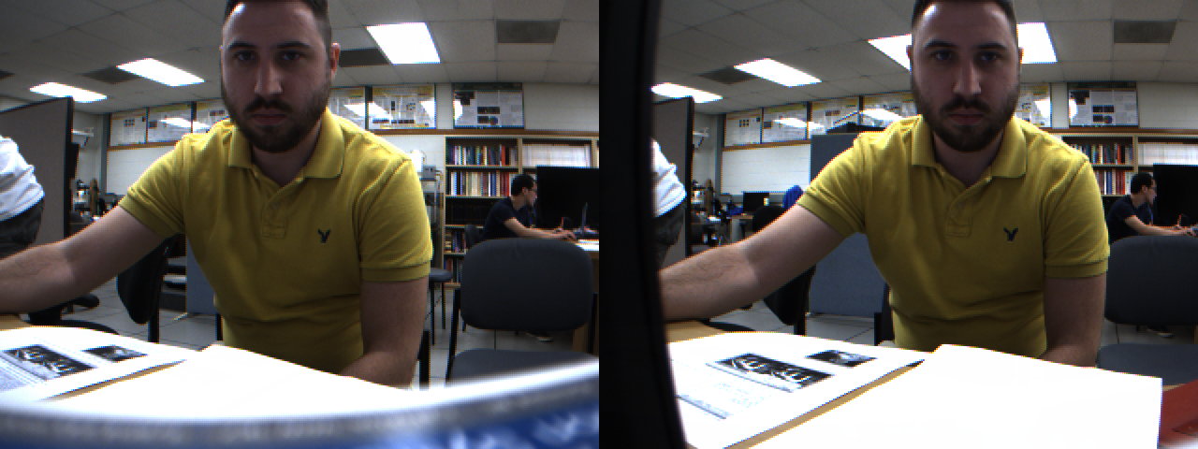

This image can be easily converted into a 3D format that makes it easy for a human to see such as anaglyph 3D or stereogram, however to get a computer to read the 3D information from these two images is complicated. A depth or disparity image is needed which is a gray scale image that uses the gray values to represent how far or close the object is to the camera. The camera does come with some software to help create a depth image, which is called a $TriclopsDemo$. After adjusting the settings in the program, the best image that the program could produce was:

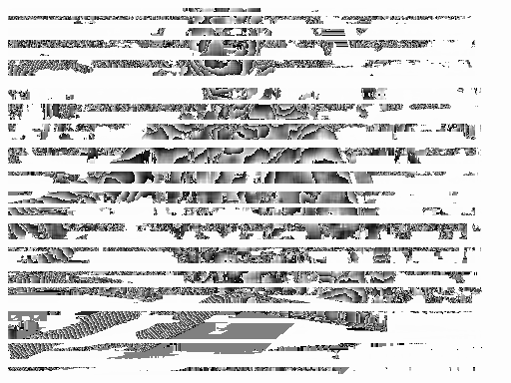

The quality of this depth image is very poor, however, $OpenCV$ could be used as an alternative to produce the depth image. $OpenCV$ has a class called $StereoSGBM$ which can convert two images into a depth image. Before attempting to get the depth image, the source image must be cleaned up. This means cropping the image to exclude information that is not needed, applying a median filter to remove noise, and finally using histogram equalization to increase the image contrast. Below is the image after it was cleaned up.

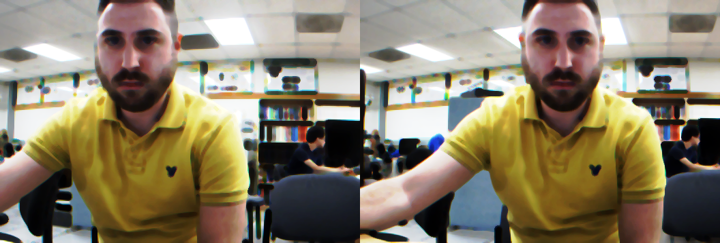

After the image was cleaned up $OpenCV$ could finally get the depth image from the two images. Below is the depth image that $OpenCV$ produced:

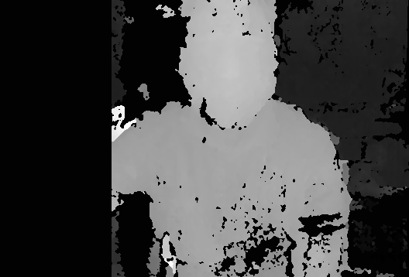

The quality of this depth image is much more accurate to actual depth of the objects in the image. The code for this depth image conversion can be found in the $ImageProcessor$ source code. $OpenCV$ uses a simple method for creating a depth image. Based on the image below, an equation can made such that it will produce a depth value per pixel. More information about this method is explained in $OpenCV$’s documentation web page (http://docs.opencv.org/3.0-beta/doc/py_tutorials/py_calib3d/py_depthmap/py_depthmap.html).

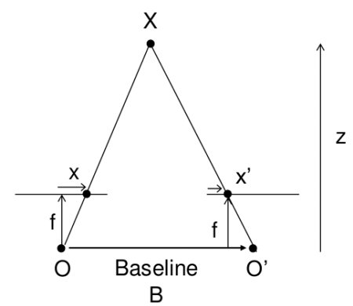 $depth=\frac{Bf}{Z}$

# Logitech C910 HD Webcam

The purpose of this experiment is to record video using the Logitech’s software for face tracking. The software reads the live view frames from the camera and determines where the face is in the image. Based on that information it will crop and scale the video so that the face is the center of the video. Below are some face positions that were tried to get the software to following the face in the video.

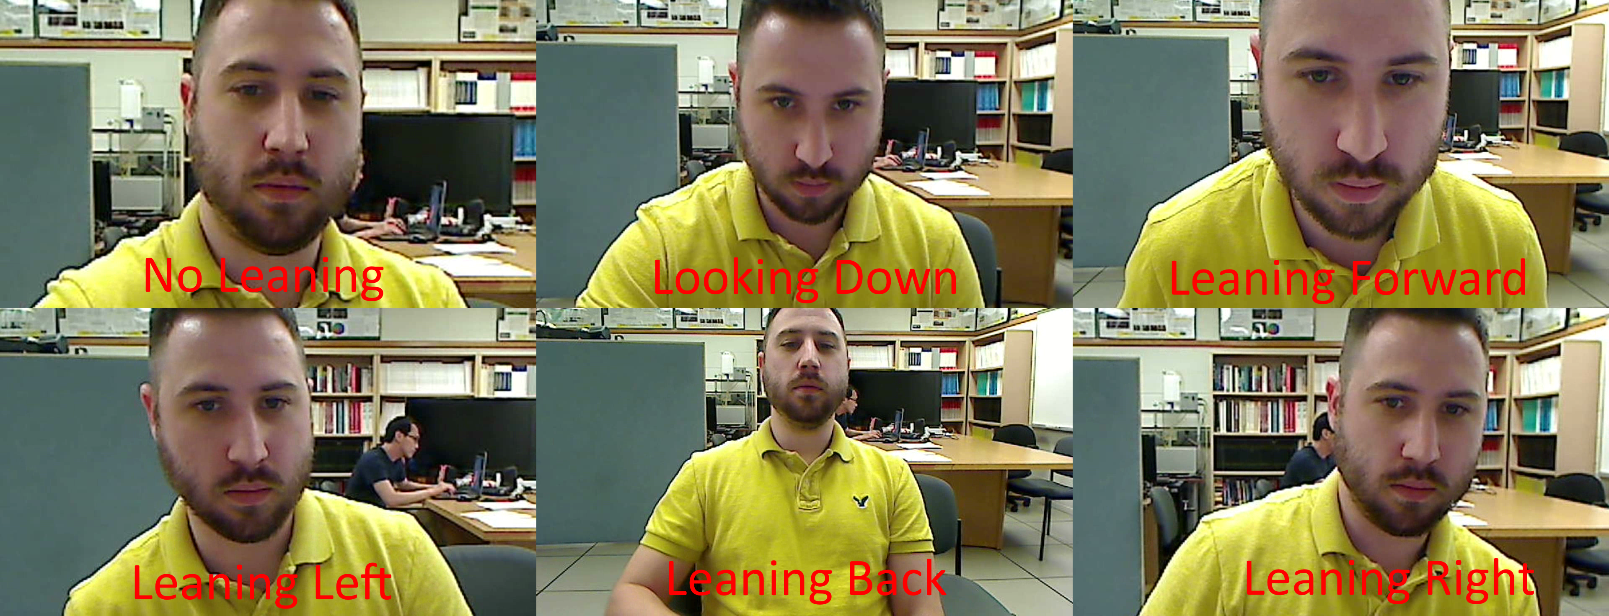

Because this software is a commercial product the source code that makes this possible is not available. However, a likely technique for face tracking is using Haar Cascades. The name describes how the algorithm works: it first has an ordered list of features that it needs to validate in order to recognize the face. The algorithm cascades across that list of features, and if any feature validation fails, it assumes that there is no face in that region of the image and it proceeds to the next region of the image. The features that are usually included but are not limited to are: the eyes, nose, and lips. It validates a feature by converting the image region into a binary image and subtracting the count of black pixels from the count of white pixels. If the difference falls within the expected range then it passes the feature validation.

Lab 2

# Microsoft Kinect

The purpose of this experiment is to capture depth images from the Microsoft Kinect camera array. Unlike the Bubblebee2 Stereo Vision Camera, the Kinect uses a single camera to capture the depth image. It can do this by using an infrared projector that projects many points of light in the scene the camera is recording. The camera is designed to pick up those infrared light dots and convert that information into a depth image. However, there are some limitations and the quality of the depth image is not very good. Below is a series of photos captured using the visible light camera.

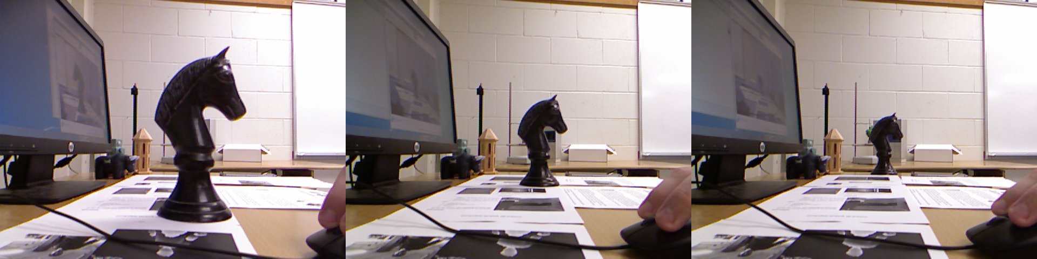

The object of interest in the images is the oversized Knight Chess piece. The object starts with a distance of 11.5 inches from the camera and incrementally moves by 11.5 inches in each of the following frames. Below are the depth images for the same images above.

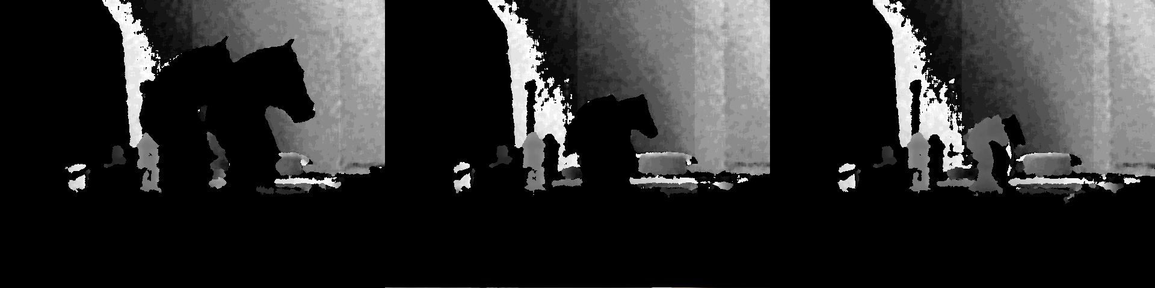

Unfortunately, it appears as though the camera array is unable to figure out where the object is, with this conundrum the object appears twice in each image. There are a few possible reasons this can happen: it is possible that the object is too close to the camera, it is also possible that the camera has some additional API settings that were not accessible with the program that was used to capture these images. Assuming that these issues could be resolved, the resolution of the depth image is very nice compared to using the Bubblebee2 Stereo Vision Camera.

NextEngine Desktop 3D ScannerThe purpose of this experiment was to get a 3D model of an object using the NextEngine Desktop 3D Scanner. This 3D scanner works a lot like the Microsoft Kinect in that it uses a projector to project light onto an object, it then uses that information to find the depth of the object in the image. It also has a rotating platform for the object and the software will spin the platform around so that the scanner can scan all sides of the object. The object that was scanned was the oversized Knight Chess piece that was used in the Microsoft Kinect experiment. Attached to this report is the .scn file that the scanner produced, the file represents a 3D mesh and texture of the scanned item. The quality of the scan was a fair approximation to the actual object, however there were some gaps in the mesh; some of which were filled by the software.

Lab 3

# Axioskop Zeiss Microscope

The purpose of this experiment is to capture images the Axioskop Zeiss Microscope. The slide sample that was used for this experiment is not known. Below are images of the same sample at varies factors of magnification.

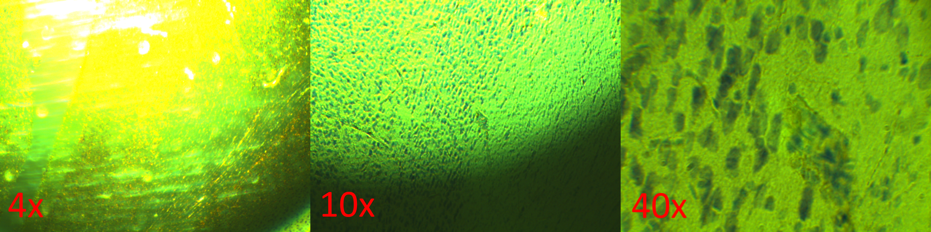

At 40x it is clear that there are many objects that are approximately the same size. Converting the same image into a binary image does make the objects more visible.

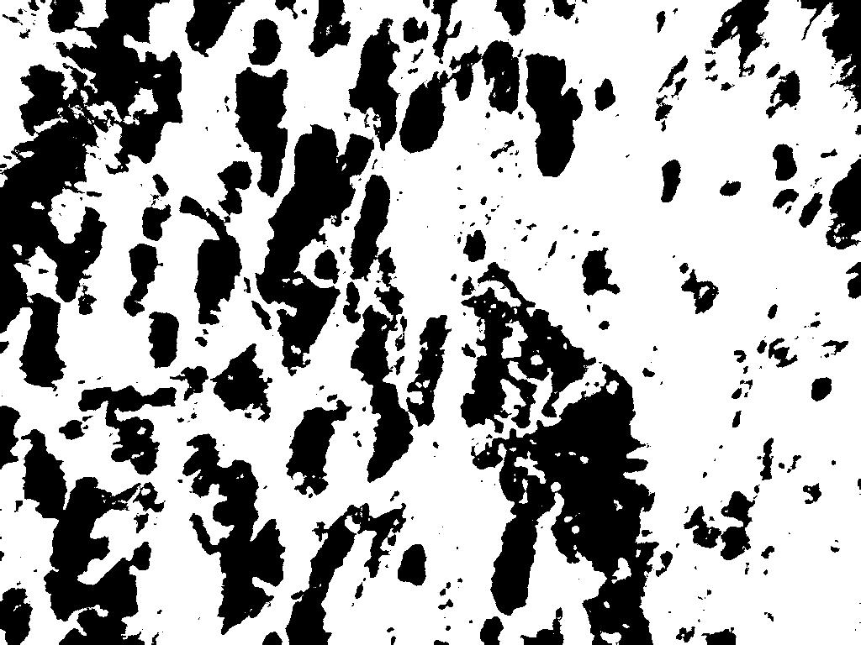

# FLIR E4 Infrared Camera

The purpose of this experiment is to capture images the using the FLIR E4 Infrared Camera. Because this camera captures images in infrared it is possible capture information about the state of an object that is not possible with visible light cameras. For example, the image below is an image of a hand print on a sheet of paper.

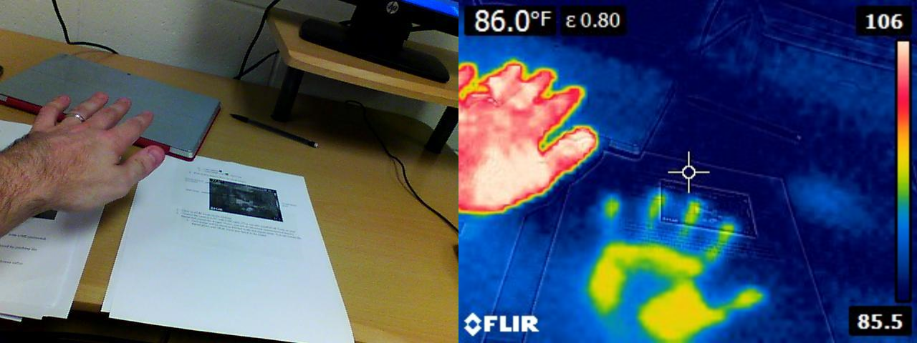

Below is an image of a face capture in infrared.

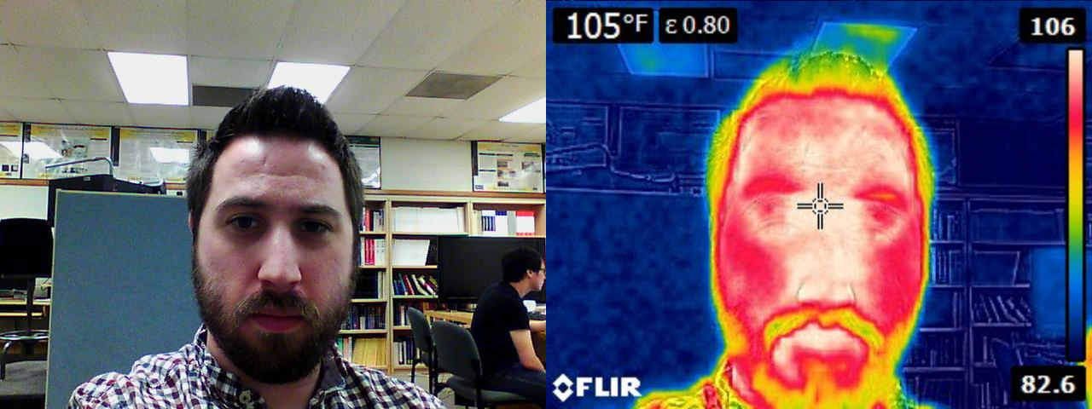

This could be useful in face tracking. The infrared image can be converted into a binary image and used as a mask to isolate the face from the image:

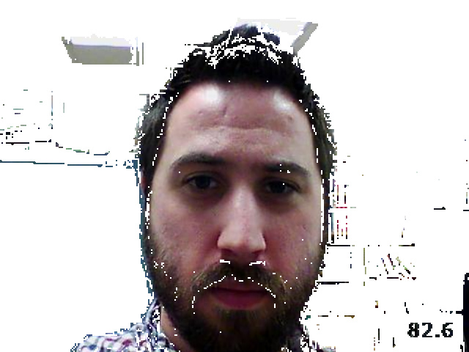

Conclusion

All 3 labs were able to shed some light on different techniques for image processing and computer vision. Lab 1 was all about depth and object recognition, lab 2 was all about 3d mapping, and lab 3 was all about using imaging tools to capture images that humans are naturally unable to see. Overall the labs showed that computers are nearly as good as humans in reading image data, and in some cases better.